**Experiment 9**

**Aim**: To create a Collaboration diagram for the project Object Detection Solutions

**Theory:**

Collaboration diagrams are used to show how objects interact to perform the behavior of a particular use case, or a part of a use case. Along with sequence diagrams, collaboration are used by designers to define and clarify the roles of the objects that perform a particular flow of events of a use case. They are the primary source of information used to determine class responsibilities and interfaces.

Unlike a sequence diagram, a collaboration diagram shows the relationships among the objects. Sequence diagrams and collaboration diagrams express similar information, but show it in different ways.

It shows the object organization as seen in the following diagram. In the collaboration diagram, the method call sequence is indicated by some numbering technique. The number indicates how the methods are called one after another. We have taken the same order management system to describe the collaboration diagram.

Method calls are similar to that of a sequence diagram. However, difference being the sequence diagram does not describe the object organization, whereas the collaboration diagram shows the object organization.

To choose between these two diagrams, emphasis is placed on the type of requirement. If the time sequence is important, then the sequence diagram is used. If organization is required, then collaboration diagram is used.

Because of the format of the collaboration diagram, they tend to better suited for analysis activities. Specifically, they tend to be better suited to depicting simpler interactions of smaller numbers of objects. However, if the number of objects and messages grows, the diagram becomes increasingly hard to read. In addition, it is difficult to show additional descriptive information such as timing, decision points, or other unstructured information that can be easily added to the notes in a sequence diagram. So, here are some use cases that we want to create a collaboration diagram for:

* Model collaborations between objects or roles that deliver the functionalities of use cases and operations
* Model mechanisms within the architectural design of the system
* Capture interactions that show the messages passing between objects and roles within the collaboration
* Model alternative scenarios within use cases or operations that involve the collaboration of different objects and interactions
* Support the identification of objects (hence classes) that participate in use cases

Notations of Collaboration Diagram

* Objects - An object is represented by an object symbol showing the name of the object and its class underlined, separated by a colon:
  + Object_name : class_name
* Actors - Normally an actor instance occurs in the collaboration diagram, as the invoker of the interaction. If you have several actor instances in the same diagram, try keeping them in the periphery of the diagram. Each Actor is named and has a role.
* Links - Links connect objects and actors and are instances of associations and each link corresponds to an association in the class diagram. A link is a relationship among objects across which messages can be sent. In collaboration diagrams, a link is shown as a solid line between two objects. An object interacts with, or navigates to, other objects through its links to these objects. A link can be an instance of an association, or it can be anonymous, meaning that its association is unspecified.
* Messages - A message is a communication between objects that conveys information with the expectation that activity will ensue. In collaboration diagrams, a message is shown as a labeled arrow placed near a link. The message is directed from sender to receiver.

**Collaboration Diagrams for the Given Projects: Object Detection Solutions**

Collaboration Diagram 1:

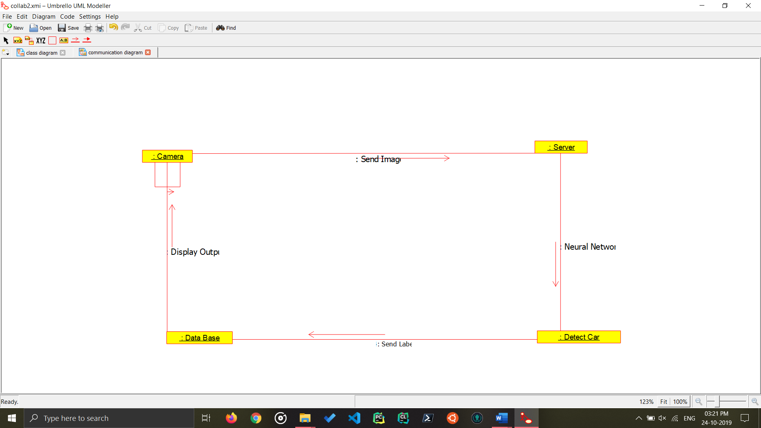

Car Parking

Collaboration Diagram for This Tells the Relation between Various Stages of a car parking detection.

Collaboration Diagram 2:

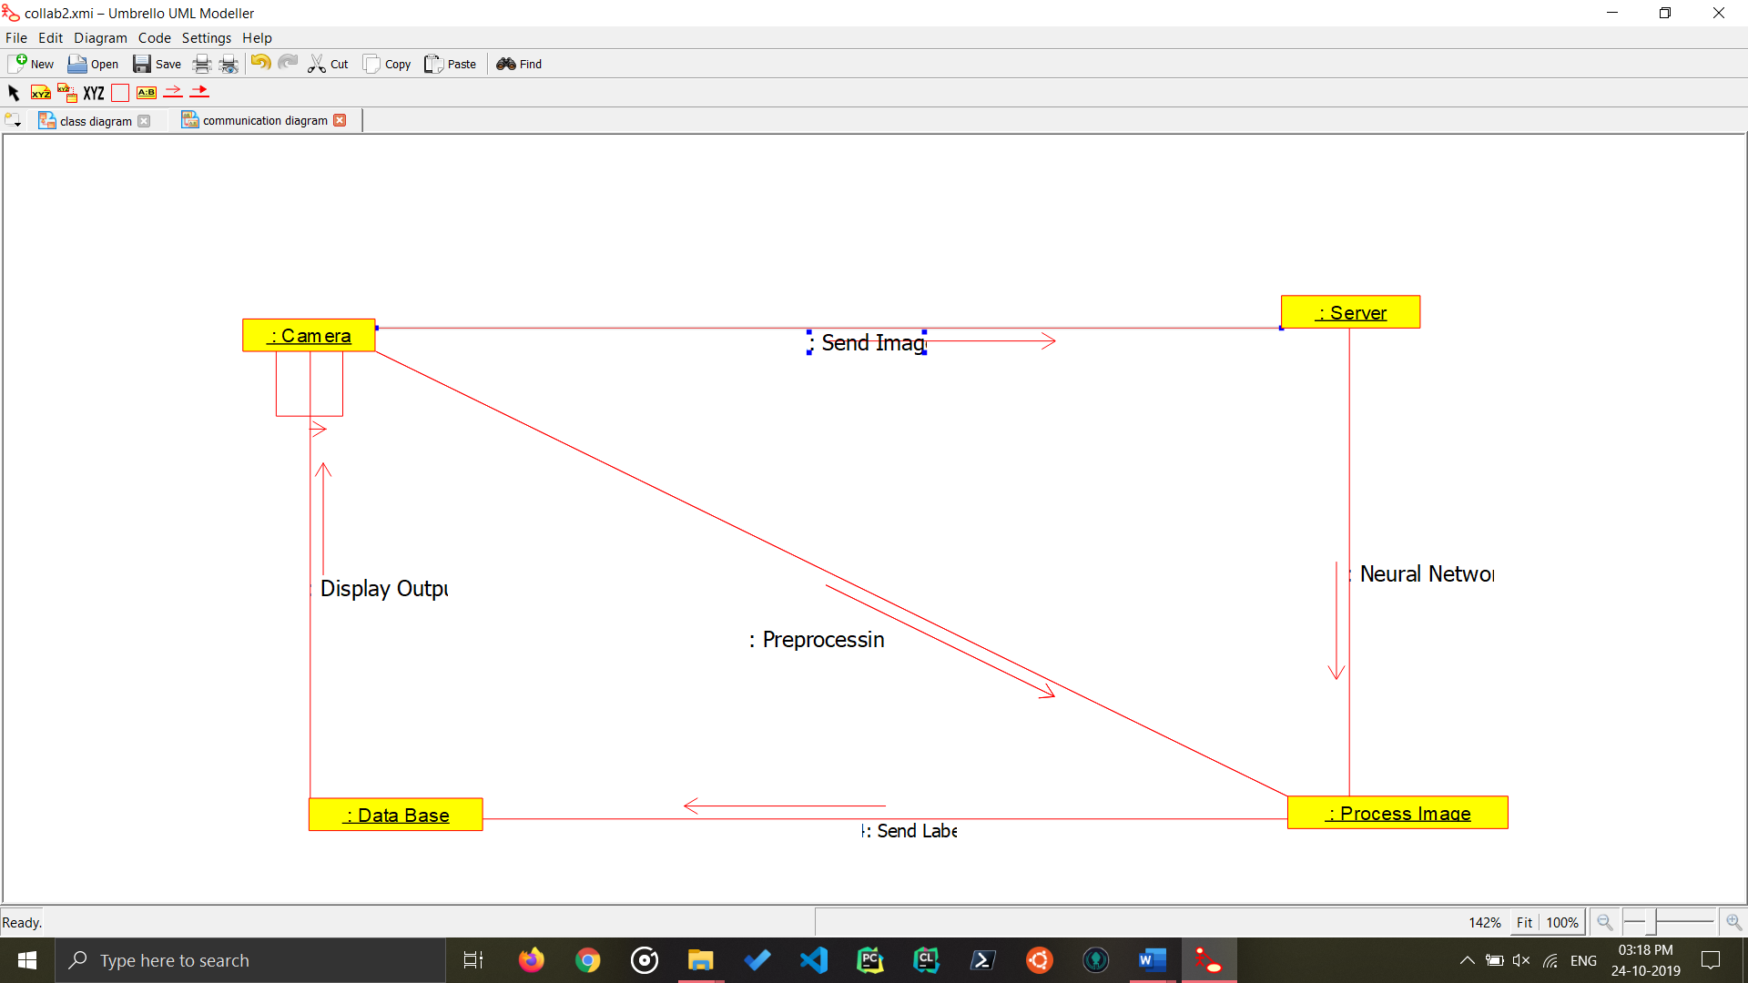

Object Detection Methodology

Collaboration Diagram for Object Detection system, It identifies the object, checks the database for the Label and then gives the user the output.

**Conclusion:**

The Collaboration Diagram for the project Object Detection Solution has been made.